[PAPER TITLE: 14 pt, Bold Face, Times New Roman, Upper case, Centre aligned]
1 line
[Author’s name, Co-authors’ names: 11 pt, Arial, Centre aligned]
1 line
[affiliation of University or Institute, City, Country 11 pt, Arial Narrow, Centre aligned]
*Corresponding author: e-mail of the author who submitted the article for publication

Abstract. The abstract should consist of at least 5-6 sentences, but no more than 200-300 words, without formulas, references, abbreviations. The abstract summaries the relevance and purpose of the research, the subject and methods of the research, the main results and conclusions. Abstract style: 10 point size, Italic, Times New Roman, first line indent 0.63 cm, left indent 0.8 cm.
1 line
Keywords: at least 3, but no more than 10, key terms or short phrases without formulas and abbreviations. Keywords style: 11 pt, Arial Narrow, first line indent 0.8 cm.
1 line
1. Introduction
1 line
The text of the article should be divided into structural parts: Introduction, Main part (theoretical part, object of research, materials and/or methods of research, technique of experimentation/calculation), Results and discussion, Conclusion (formulation of the main results; comparison of the results with existing data on the theme; assessment of scientific novelty and practical value of the results, possible prospects of their use).
The volume of the article, including the bibliography, should not exceed 10 pages of text, including tables, formulas, figures (no more than 10) and the list of references (no more than 35), typed on a computer in Microsoft Word. The volume of the review article should not exceed 20 pages, including no more than 15 figures and the list of references (no more than 45).
Use Times New Roman font and A4 format (210×297 mm) in portrait orientation with margins 2.7 cm (top), 2.4 cm (bottom), 2.0 cm (left), 2.0 cm (right); binding 0 cm.
Main Text (Main Text style): 11 pt, Times New Roman, first line indent 0.8 cm, spacing 0 pt before and after, single line spacing, justified, no hanging line, no hyphenation.
Sections (Sections style): 11 pt, Arial first line indent 0.8 pt. Sections should be numbered with Arabic numerals. Subsections (second-level headings) should be numbered 1.1, 1.2, 1.3, …, etc.; third- level headings should be numbered 1.2.1, … , etc.
Figures should be prepared in a digital form suitable for direct reproduction. Figures shall be submitted on the separate sheets or can be included into the text. Figures (Figures style): text wrapped, centered. A resolution of 300 dpi is recommended.
Formulas (Formulae style): left-aligned with indent 0.8 pt, numbers right-aligned, Equations have to be written using the equation editor built into Word or the plugin MathType!:
, (1)
with no first line indent below (After Formula style).

1 line
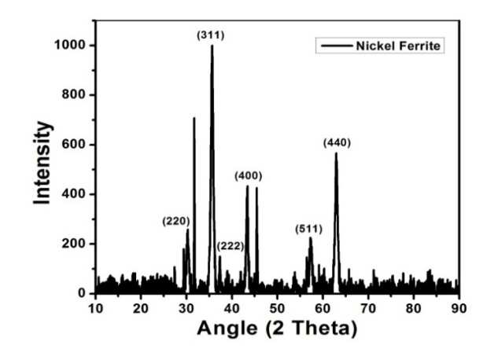
Fig.1. Figure Legends (Figure Legends style): 10 pt, Times New Roman, centered, first line indent 0 pt.
1 line
Tables must be inserted into the text. Table should be consecutively with Arabic numerals and should be cited in the text by number. Each table must be mentioned at least once in the text, and in proper numerical order.
1 line
Table 1. Table Legends style: 10 pt, Times New Roman.
1 line
Funding
The work was performed as part of the state assignment of the ххх. (11 pt, Arial Narrow)
1 line
Acknowledgements
This work was carried out …(11 pt, Arial Narrow)
1 line
Conflict of interest statement
The authors declare that they have no conflict of interest in relation to this research, whether financial, personal, authorship or otherwise, that could affect the research and its results presented in this paper. (11 pt, Arial Narrow)
1 line
References
References no more than 35 reference. (References style): 10pt size, Times New Roman, first line indent 0.63 pt. Heading: 11pt, Times New Roman, centered, all capitalized. Follow the templates and examples below.
1 line
- Fitzpatrick R. (2008) Maxwell's Equations and the Principles of Electromagnetism. Richard Jones & Bartlett Publishers, 438. https://books.google.kz/books/about/Maxwell_s_Equations_and_the_Principles_o.html?id=4QaVSxxn
- Zhanabaev Z.Zh., Karibayev B.A., Imanbayeva A.K., Namazbaev T.A., Ahtanov S.N. (2019) Electrodynamic characteristics of wire dipole antennas based on fractal curves. Journal of Engineering Science and Technology. 14(1), 305-320. https://jestec.taylors.edu.my/Vol%2014%20issue%201%20February%202019/14_1_22.pdf
- Ibrayev N.Kh., Kucherenko M.G., Temirbayeva D., Seliverstova E. (2022) Plasmon-activated Forster energy transfer in molecular systems. Optics and Spectroscopy. 130(5), 569-574. DOI: 10.21883/EOS.2022.05.54441.1-22
- Ermachikhin, A., Litvinov, V., Kholomina, T., Maslov, A., & Trusov, E. (2022). Automated measuing system for investigating temperature dependence of low-frequency noise spectra in electronic elements and structures. Eurasian Physical Technical Journal. 19, 4(42), 51–57. https://doi.org/10.31489/2022No4/51-57
- Spitans S., Franz H., Baake E., Jakovics A. (2017) Large-scale Levitation Melting and Casting of Titanium Alloys. Proceedings of the VIII International Scientific Colloquim "Modelling for Materials Processing", Riga, Latvia, 59-66. https: // doi.org/10.22364/mmp2017.8
- Bochkarev V.P. (2020) Development of physical and chemical principles for assessing the effect of surface energy on the properties of materials and processes for microelectronic technology. Doctor Diss. of the Techn. Science degree, Moscow, 299 p. [in Russian] https://www.dissercat.com/content/razvitie-fiziko-khimicheskikh-printsipov-otsenki-vliyaniya-poverkhnostnoi-energii
- X-ray Oxford-Instruments Microfocus Tubes. Available at: oxford-instruments.com/products/ x-ray-tubes-and-integrated-sources/ microfocus-x-ray-systems (Jan13, 2020).

!!! All references should be numbered as they are used in the text ([1], [2-4]) and listed at the end of the article in ascending order of numbers. The percentage of self-citations, i.e. references to publications of all co-authors, should not exceed 25%. Authors may submit References in accordance with international publication requirements with standard abbreviations. Use the APA style bibliographic citation format.
1 line
AUTHORS’ INFORMATION
Full name of authors - Academic degree, academic title, place of work or study, organization, city, country; SCOPUS Author ID, ORCID iD; contact information (e-mail, phone). (11 pt, Arial Narrow)

